**DAILY ONLINE ACTIVITIES SUMMARY**

|  |  |  |  |  |  |  |  |  |
| --- | --- | --- | --- | --- | --- | --- | --- | --- |
| **Date:** | **02-7-2020** | | | | | **Name:** | **poojashree** | |
| **Sem & Sec** | **8th sem A sec** | | | | | **USN:** | **4al16cs065** | |
| **Online Test Summary** | | | | | | | | |
| **Subject** | | **sms** | | | | | | |
| **Max. Marks** | |  | | **Score** | | |  | |
| **Certification Course Summary** | | | | | | | | |
| **Course** | **Introduction to cyber security** | | | | | | | |
| **Certificate Provider** | | | **Great learning academy** | | **Duration** | | | **5.5hr** |
| **Coding Challenges** | | | | | | | | |
| **Problem Statement:**  **1. print the c program for counting number of vowels using null characters** | | | | | | | | |
| **Status:completed** | | | | | | | | |
| **Uploaded the report in Github** | | | | | **yes** | | | |
| **If yes Repository name** | | | | | **Poojashree** | | | |
| **Uploaded the report in slack** | | | | | **yes** | | | |

**Online test**

**----------no marks -----------**

**Certification course**

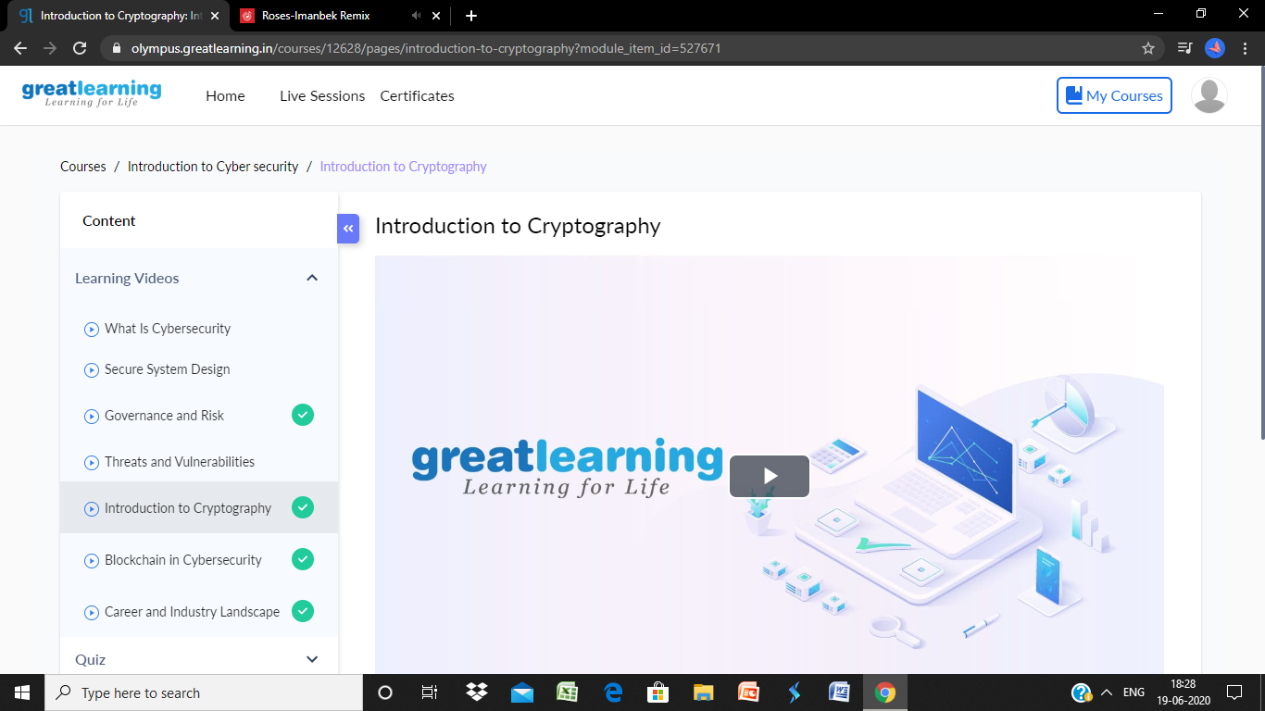

**Coding**

**Program 1**

counting the number of vowels by using the null character.

1. #include<stdio.h>
2. **void** main ()
3. {
4. **char** s[11] = "javatpoint";
5. **int** i = 0;
6. **int** count = 0;
7. **while**(s[i] != NULL)
8. {
9. **if**(s[i]=='a' || s[i] == 'e' || s[i] == 'i' || s[i] == 'u' || s[i] == 'o')
10. {
11. count ++;
12. }
13. i++;
14. }
15. printf("The number of vowels %d",count);
16. }